February 2, 2017

Brandon Hurley, Chairman
Texas Low-Level Radioactive Waste Disposal Compact Commission
333 Guadalupe St., #3-240
Austin, TX 78701

Re: One Time Minor Amendment Request to Bionomics Import Agreement #2-0129-00

Dear Mr. Hurley,

Bionomics needs a one-time minor amendment to add the States of MT, OR and UT to our Import Agreement #2-0129-00, specifically Removal Letter #1 which covers shipment Thermo 8A. This is a shipment of sources from the Thermo Process Instruments facility destined for the WCS facility on February 3, 2017.

Our present Agreement does not include the States of the Northwest Compact and included in this shipment are the States of MT, OR and UT. Thermo Agreement #2-0128-00 does include the Northwest Compact States however this shipment is not being made under that agreement, even though this is waste from that facility. The Northwest Compact has authorized the disposal of any Northwest Compact material generated by the Thermo facility at the Andrews facility.

There appears to be a method under Rule 675.23(l)(3) that would allow the addition of the States MT, OR and UT to our Import Agreement without having to go before the entire Commission. We are only seeking the addition of these three states for this specific shipment. We are not requesting or needing any changes to the volume of waste or the city of waste to be disposed.

Thank you for your consideration and feel free to contact me with any questions regarding this amendment.

Sincerely,
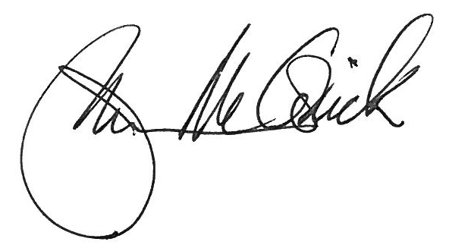
John McCormick

