October 20, 2022

Mr. Brandon Hurley
Texas Low-Level Radioactive Waste Disposal Compact Commission
505 West 15th Street
Austin, Texas 78701
administration@tllrwdcc.org
Brandon.hurley@tllrwdcc.org

Subject: Tennessee Valley Authority Import Agreement Amendment Request

Dear Mr. Hurley:

Tennessee Valley Authority is requesting an amendment to its Import Agreement Number 2-0361-00.

We are requesting the addition of a new Waste Description. This waste description is “Heat Exchanger”. This is due to a replacement project that has been added to our upcoming outage.

If you have questions, please contact me by phone or by email at dfrowe@tva.gov.

Sincerely,
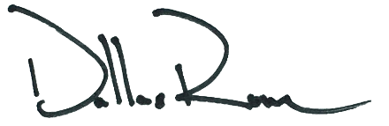

Dallas Rowe
Radwaste CFAM
W. 423.751.2529
M. 423.414.1451
E. dfrowe@tva.gov

